ECONOMIC POILICY ASSESSMENT IN POST-COVID WORLD
STANIMIR KABAIVANOV
University of Plovdiv Paisii Hilendarski, Faculty of Economics and Social Sciences
Plovdiv, Bulgaria
stanimir.kabaivanov@uni-plovdiv.bg

VENETA MARKOVSKA
University of Food Technology, Business Faculty
Plovdiv, Bulgaria
v_markovska@uft-plovdiv.bg

Extended Abstract
Economic research is given the blessing and the curse of being all the time at the top of the news and our attention – simply because its successes and failures impact the daily life and wellbeing even for individuals, that are not related directly to the research. Also due to the fact, that economic policies and research often go in parallel, it is not unlikely to have the economics as science take all the blame for the misfunction of otherwise political decisions. Yet there are some objective reasons on why economic research results are often criticized:
- static nature of the results, which may take the form of studying only a specific time interval or a reduced set of inputs (like for example putting focus on a single area or country);
- applicability and practical use, which may vary across different studies;
- transparency (in terms of being able to reproduce quickly and confirm the findings) and adaptability of the research results (in terms of being able to easily modify the applied scientific methods in accordance with different needs and level of understanding of the target audience).
In this paper we suggest and demonstrate an approach how to use simulation and interactive data processing to overcome the aforementioned issues. For the last two years, SARS-CoV-2 pandemic offered us a unique opportunity to conduct studies on our economies put to a serious and unexpected stress test. Due to the fact, that countries had to react at the same time to the same threat, it was possible to compare in “laboratory conditions” the impact and short-term effects on different policies and counter measures. But it should not require a large scale epidemy or war to be able to carry out tests and estimate the effects of different policies. We develop and test a generic approach for assessment of economic policies impact, based on real time data processing, pluggable econometric models and Monte Carlo simulations with user-specified controllable scale and complexity. There are two important aspects of our study:
- development of continuous and logically sound approach to combining different data sources, into a model that can be used to develop different scenarios and estimate the effects of a policy;
- use of interactive (dashboard-oriented as shown on Figure 1) models, that allow to adjust model parameters and re-use existing policy assessment methods with new data and under different assumptions/conditions.
In addition, to specifying common steps for the analysis, we conduct tests of the suggested approach by analysing the impact of COVID restrictions in different EU countries and demonstrate how policies for supporting economic development and recovery can be assessed with the help of Monte Carlo simulations.
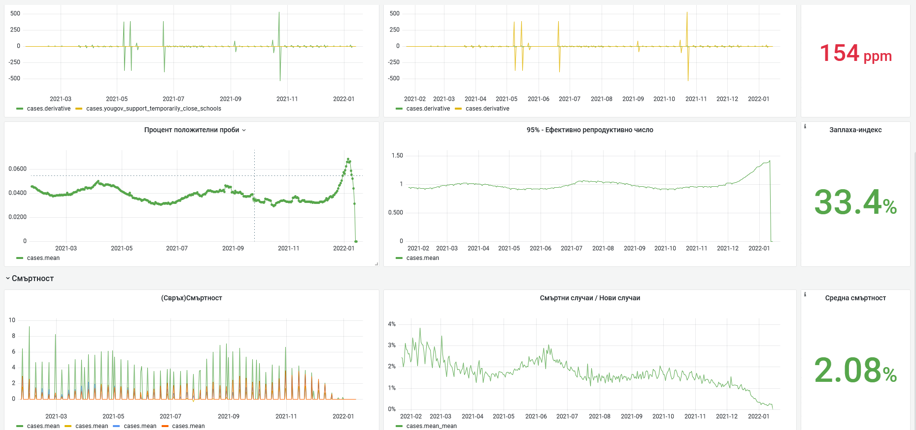
Figure 1. Example of a configurable dashboard with study results

Keywords: Monte Carlo, MLE estimation, policy impact simulation, pandemic effects
JEL Classification: G17, C58, C63

The length of the abstract should be between 300 and 500 words. The abstract should explicitly state the problem that the authors seek to solve or the research question, describe the method or the process by which the research was conducted, and briefly list the main results or outcomes. When deemed relevant, the abstract should develop on the implications of the findings for policy-making. The abstract should be submitted by e-mail at euconomics@uaic.ro no later than on March 1st, 2023. Each participating author is allowed to submit up to two full papers or abstracts.

